Name: Pheakdey Luk **Assignment 1**

ID: 986591

R-1.1 Graph the functions 12n, 6n log n, n2, n3, and 2n using logarithmic scale for the x- and y-axes; that is, if the function value f(n) is y, plot this as a point with x-coordinate at log n and y-coordinate at log y.

* **R.1.1 answer:**

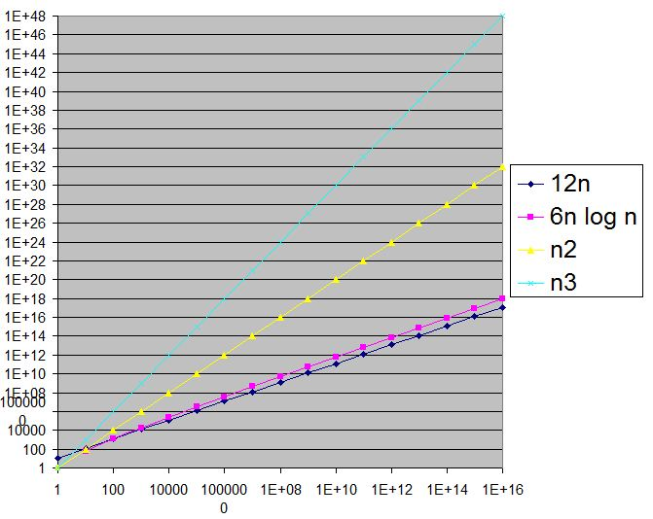

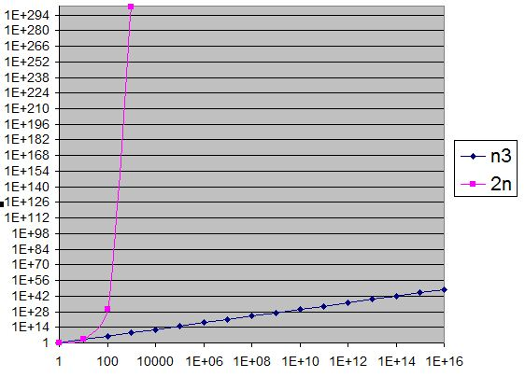

R-1.2 Algorithm A uses 10n log n operations, while algorithm B uses n2 operations. Determine the value n0 such that A is better than B for n ≥ n0.

* **R-1.2 Answer:**

For n0 = 100,

10nlogn = 10 * 100 * 10 = 10000

n2 = (100)2 = 10000

For n0 >100, A is better than B.

R-1.6 Order the following list of functions by the big-O notation.

**R-1.6 Answer:**

1/n < log log n < √n < 5n < n log n < 2n log2 n < 4n3/2 < 4log n < n2 log n < n3 < 2n < 4n

R-1.10 Give a big-O characterization, in terms of n, of the running time of the Loop1 method below:

**R-1.10 Answer:**

|  |  |
| --- | --- |
| Algorithm Loop1(n)  s ← 0  for i← 1 to n do  s← s+ i | O(1)  O(n)  O(n)  Total running time = O(n) |

R-1.14 Perform a similar analysis for method Loop5 below:

**R-1.14 Answer:**

|  |  |
| --- | --- |
| Algorithm Loop5(n)  s ← 0  for i← 1 to n2 do  for j← 1 to i do  s← s+ i | O(1)  O(n2)  O(n4)  O(n4)  So total running time = O(n4) |

Prove: logbxa =alogbx

From the definition, Y = logb x

=>x = bY

=>xa = ( bY)a

=>logb Xa  = Ya

=>logb Xa  = alogb X